THE AMERICAN PRESIDENTIAL ELECTIONS 2008

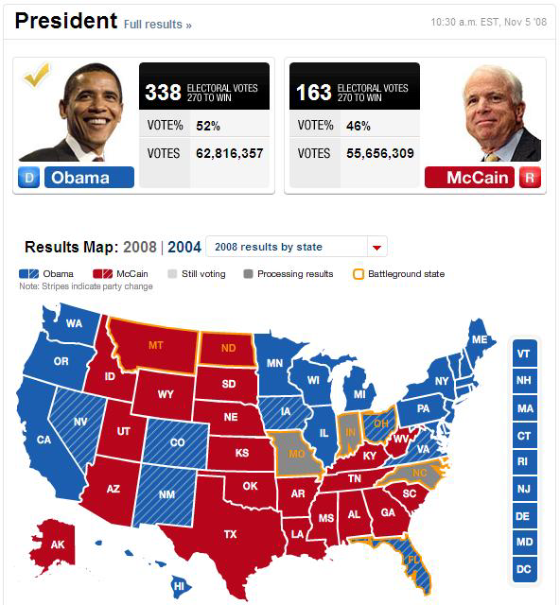

Obama’s hope for change
Domestic issues:
Taxes
Social security
Finances
Foreign policy
The war in Irak
Afghanistan
Terrorism

