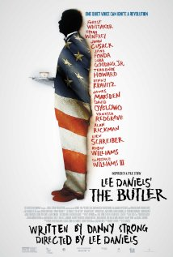
THE BUTLER : QUIZ
Circle the right answer
1. Where does the action take place ?
a . In France b. in the USA c. in Italy
2. The first picture of the film shows the main character :
a. at home b. in a cotton field c. at the White House
3. What happens to young Cecil ‘s father ?
a. He is shot dead b. he dies in a car accident c. he dies in the war
4. His first job as a young man was…
a. in a hotel b. in a shoe shop c. in a cinema
5. Why isn’t his wife happy ?
a. her husband cheats on her b. he is never home c. he wants to be the next
president of the USA
6. Why does his older son leave home ?
a .to get married b. to find a job c. to go to university
7. His son goes to prison for 3 months…
a. in Florida b. In Mississippi c. in Texas
8. His younger son was killed…
a. in the war in Irak b. in the Vietnam war c. in the war in Iran
9. The massacre in Selma , Alabama was called « Bloody …. »
a. Monday b. Wednesday c. Sunday
10. President Kennedy…
a. was killed in a car accident b. was assassinated c. died in his sleep
11. What present did Kennedy’s wife give Cecil ?
a. her husband’s shirt b. her husband’s shoes c. her husband’s tie
12. President Eisenhower grew up…
a. on a farm b. in a big city c. in France
13.Cecil Gaines wants to be paid :
a. as much as a white man b. more than a white man c. less than a white man
14.His wife died while
a. having a bath b. doing her shopping c. having breakfast
15.Pt Reagan’s position concerning the apartheid in South Africa was…
a. for b. against c. indifferent
16. How many presidents did Cecil Gaines work for ?
a. 4 b. 5 c. 8
17. How long did he work at the White house ?
a. 10 years b. 15 years c. more than 20 years
18. Cecil Gaines voted…
a. for Obama b. against Obama c. didn’t vote
19. His older son was elected…
a. at the White House b. at the Congress c. at the Senate
20. The last picture of the film shows Cecil Gaines…
a .going home b. going to meet Obama c. going to a party

