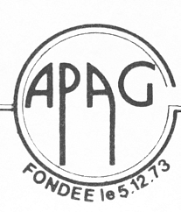
Association des Professeurs d’Anglais de la Guadeloupe

Rallye Anglais  Edition 2005 – Epreuve de sélection – Lycées  DUREE : 1 heure | Etablissement : | Composition de l’équipe (nom, prénom, classe)
Temps : | NOTE : | Classement :

N° I : The following are famous quotations from famous people. Select the right answer:
1. “Freedom is not worth having if it does not include the freedom to make mistakes…”
MalcolmX … L. ARMSTRONG M. GANDHI

2.”Love all, trust a few. Do wrong to none.”
SHAKESPEARE … Oscar WILDE… Charles DICKENS…

3. “ Love is or it ain’t. Thin love ain’t love at all…”
Hillary CLINTON Mother THERESA Toni MORRISON

4. “ Every nation in every region now has a decision to make. Either you are with us, or you are with the terrorists.”
JF KENNEDY George W. BUSH A. LINCOLN

5. “ We must learn to live together as brothers or perish together as fools.”
Sir Winston CHURCHILL A. SCHWARZENEGGER Martin Luther KING

N°II. SHAKESPEARE’S DATES OF BIRTH AND DEATH : Use the clues to find these dates.
Shakespeare died the same year as Miguel de Cervantes. When Cervantes died he was 69 years old. When he was born Christopher Columbus had arrived in America 55 years before. When Shakespeare was born Cervantes was 17.
- Shakespeare’s year of birth :............................................................
-Shakespeare’s year of death : ..........................................................

N° III. PROVERBS: Use the boxes to match the English to the French or the Creole.

a. Boys will be boys.
b. It’s the last straw that broke the camel’s back.
c. Forewarned is forearmed.
d. Birds of a feather flock together.
e. It never rains it pours.
f. Like father, like son.
- Un homme averti en vaut deux.
- Pli ou chiré, pli chyen chiré ou.
- Il faut que jeunesse se passe.
- Chyen pa ka fè chat.
- Menn bèt, menn pwèl.
- C’est la goutte qui fait déborder le vase.

English proverbs | a | b | c | d | e | f
French or Creole | ……… | …….. | …….. | …………. | …………… | ..................

N°IV. The CHATROOM. Pick out the “faux amis” and provide the appropriate words

Deng: Hello! I’m Deng, but my surname’s Dinky.
Kevin: Nice to meet you. I’m Kevin. Are you on vacancy here ?
Deng : Actually I’m in car location and I’ve just moved here. What about you ?
Kevin: My occupation ? I’m a medecine.
Deng : Wow ! You look so young. D’ you have a family ? A flatmate ?
Kevin : I live on my own. I’m too lunatic to support anyone.

Faux amis
Right words

N°V. On the CHAT AGAIN. Underline the mistakes. Write the correct forms in the boxes.
We realize that many natural disasters hitted the world in 2004 , earthquakes, hurricanes, landslides, floods and even tsunamis. Many peoples were leaved homeless and thousands dead in tragics conditions. Everybody were affecting but the disasters took the heaviest toll among the poors. I hope that 2005 will be far best than the last year.

N°VI. ALL CATEGORIES. Fill in the boxes.
nouns | verbs | adjectives | adverbs
 |  | strong
 | harm
 |  | pleasant
threat
 | madden
 |  |  | frightfully

N°VII. THE QUIZ.
2. What is the only island in the Caribbean which exploits OIL?

1. Grapefruit, tamarind, pawpaw, plum, cherry, pineapple, ackee
Which one is the English for PAPAYE ?

3. Which Caribbean island was devastated by Hurricane Ivan and is famous for its spices ?

5. Which island celebrates crop over ?

4. Who is the Prime Minister of Saint-Lucia ?

N° VIII. NATIONALITIES
COUNTRIES | ADJECTIVES
Finland
 | Swedish
 | Thai
Switzerland
 | Welsh
The Netherlands

N°IX. THINGS AND EVENTS
- The emblem of the American democratic party.
- The emblem of the American republican party.
- The Festival of lights celebrated by Hindus, Sikhs and Jains.
- A loose association of 48 independent nations which were once part of the British Empire.
- The ship which carried the Pilgrim Fathers from England to Plymouth in 1620.
- The national symbol of Wales.

Write the appropriate letter in each box
The Commonwealth | Diwali | The donkey | The Mayflower | The leek | The elephant

N° X. LANGUAGE: MCQ . Circle the appropriate letters for the right answers.
1. How does a frog differ.................a toad. a) of b)from c) against

2. He has taken the umbrella ................. was in your bedroom. a) what b)who c) which

3. Since you ........ she hasn’t been the same. a) have left b) leave c) left

4.The French hostages stayed in Irak .............. months a) since b) for c) ago

5. Your parents expect you ........ hard at school, don’t they ? a) work b) working c) to work

6. Let them ........ what they want. a) to do b) do c) doing

7. Three months ago, a hurricane ......... havoc in Haiti a) played b) has played c) plays

8. The terrorists made everybody ............... about them a) speak b) spoke c) to speak

9. Don’t say .......... ; I understand ! a) nothing b) anything c) something

N°XI. TIME PUZZLE
. 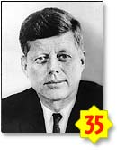 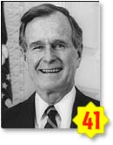 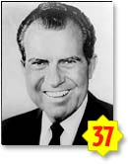 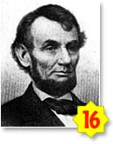 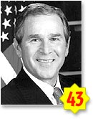 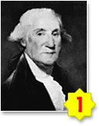
1
2
3
4
5
6

- Reorder these American presidents in the chronological order :

............................................................................................................................

- Give the name of the first president of the United States

3.Which COUNTRY has this flag?

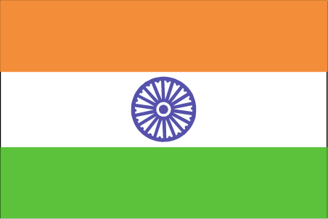

N°XII JUMBLED SENTENCES: Who says what?
a. If only I hadn’t said that to her. 1. Yes, of course.
b. I’ m sorry I’m late. 2. Has she really? How wonderful!.
c. My mother’s just had her first
novel accepted. 3. Oh that’s all right.
d. You couldn’t give me a hand,
could you? 4. Ah well! That’s life!

Just write the letters and the numbers indicating the sentences in the appropriate bubbles in those pictures:
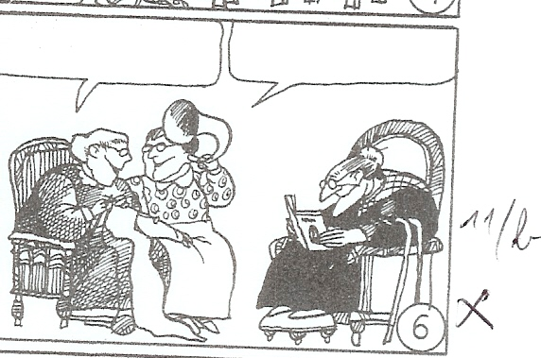 | 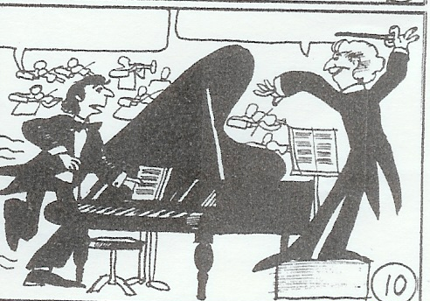 | 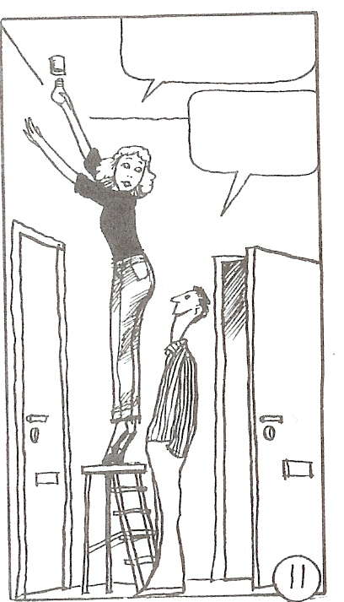 | 